**Planit!**

**System Architecture Diagrams**

**Advisor: Professor Kasprzyk**

**Mock Ups**

**Planit! Home Page:**

White board mockup.

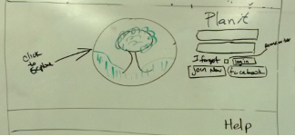

Balsamiq mockup.

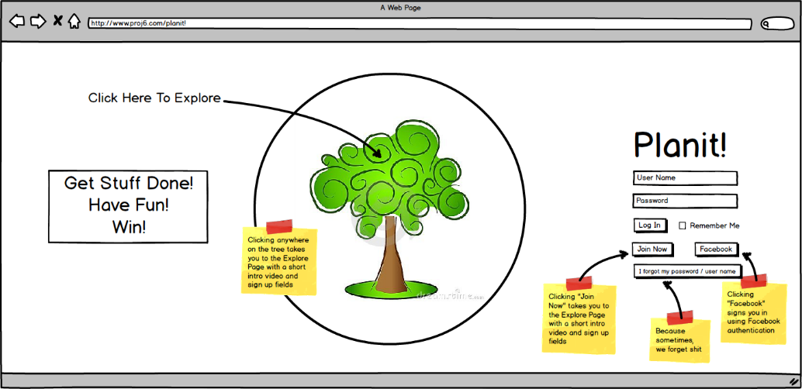

**Navigation Bar:**

White board mockup.

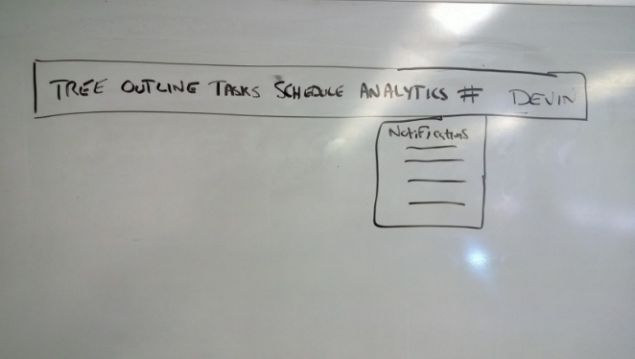

**Tree View:**

White board mockup.

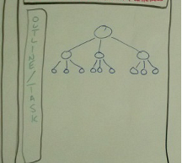

Balsamiq mockup.

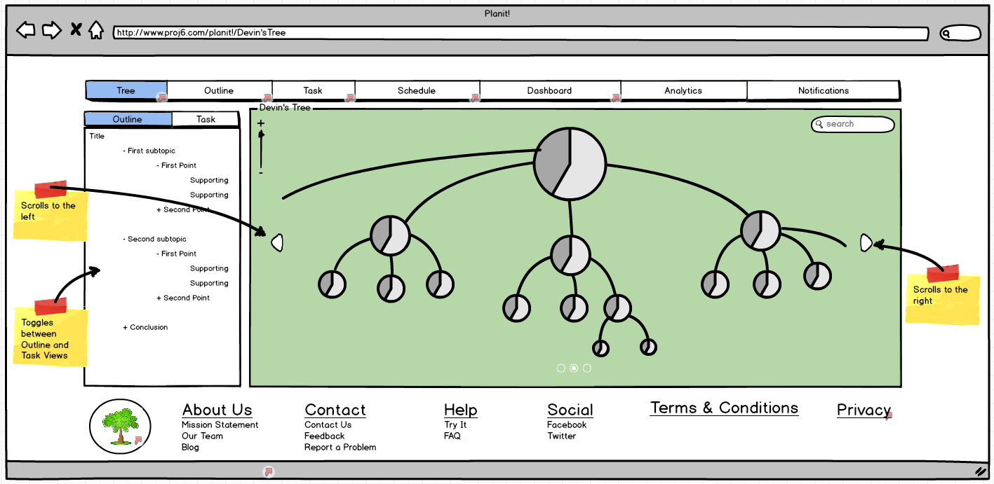

**Outline View:**

White board mockup.

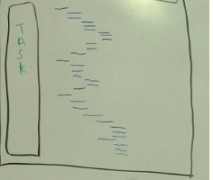

Balsamiq mockup.

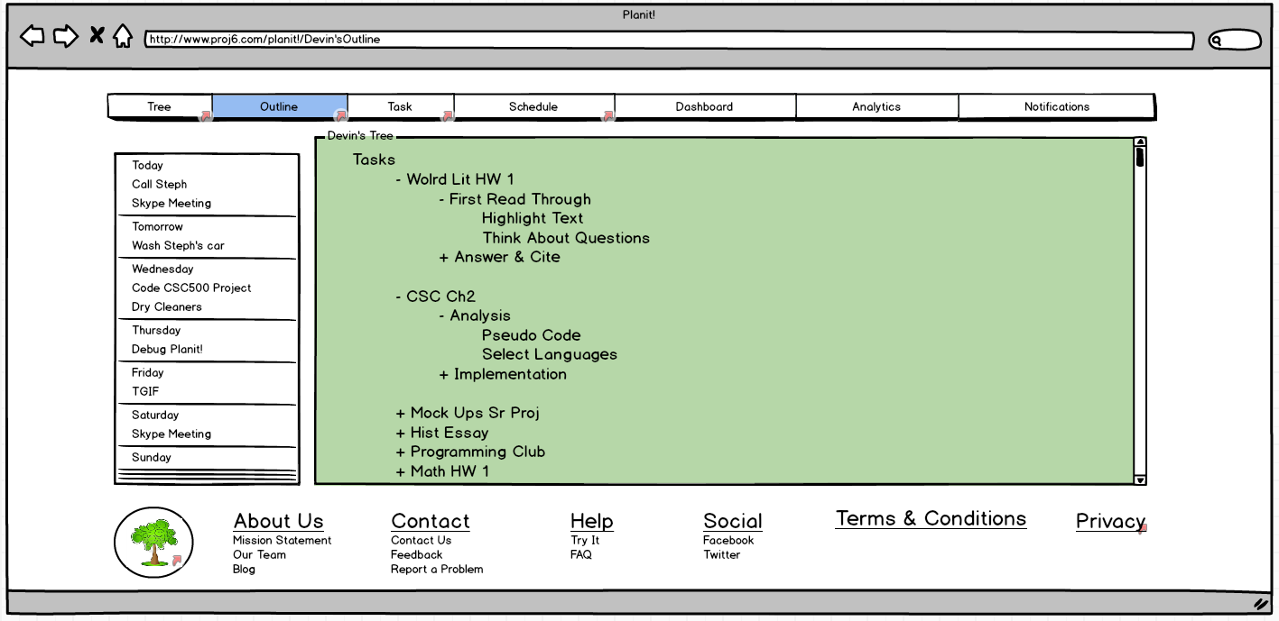

**Schedule View:**

White board Mockup.

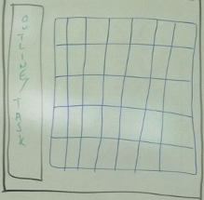

Balsamiq mockup.

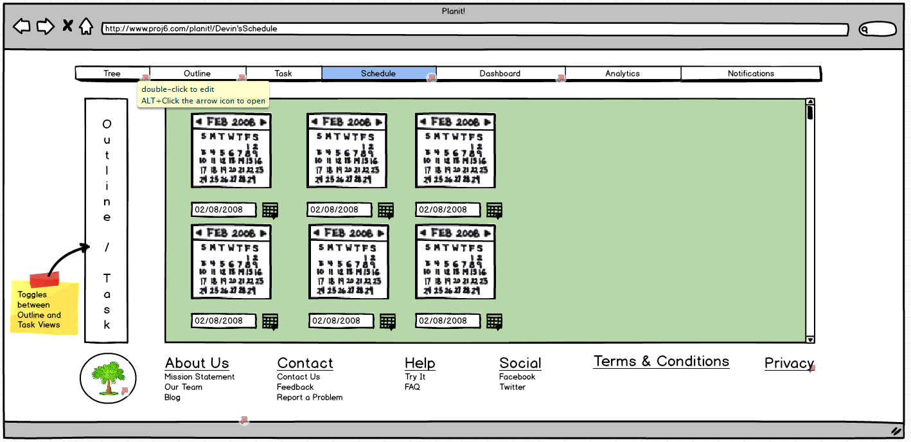

**Task View:**

White board mockup.

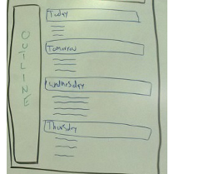

Balsamiq mockup.

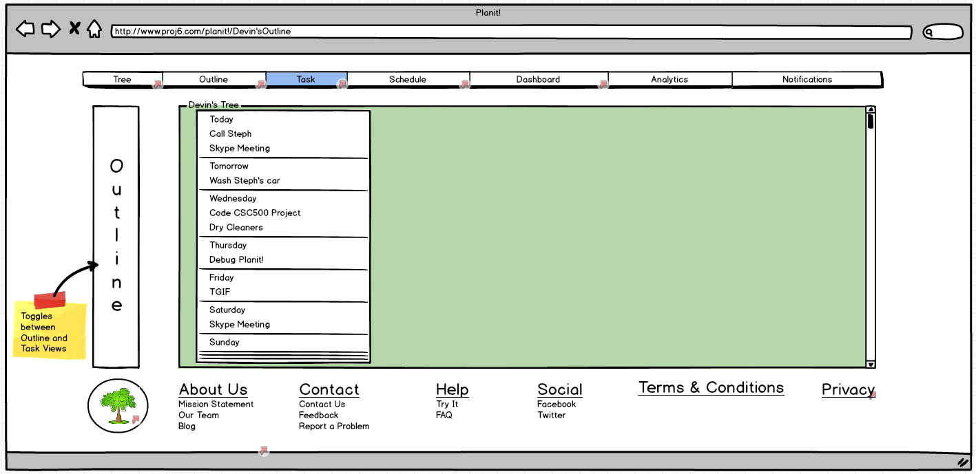

**Dashboard:**

Balsamiq mockup.

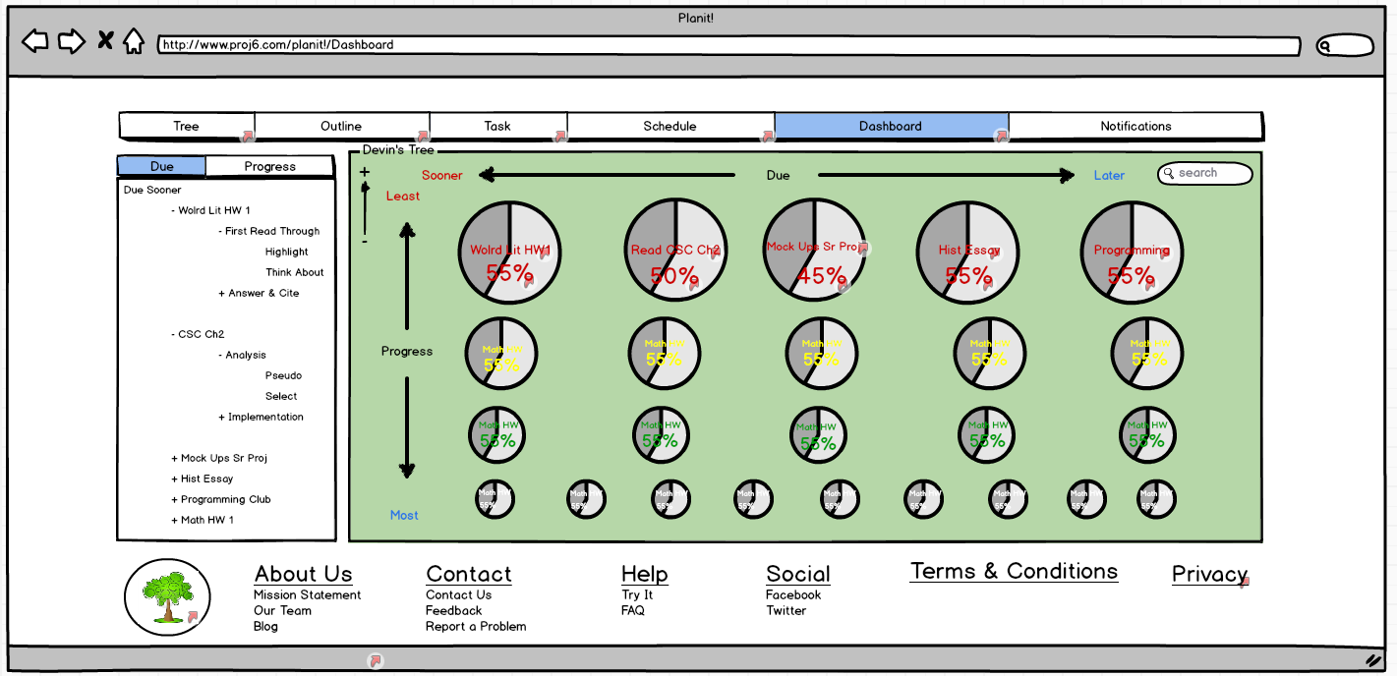

**Mission Statement:**

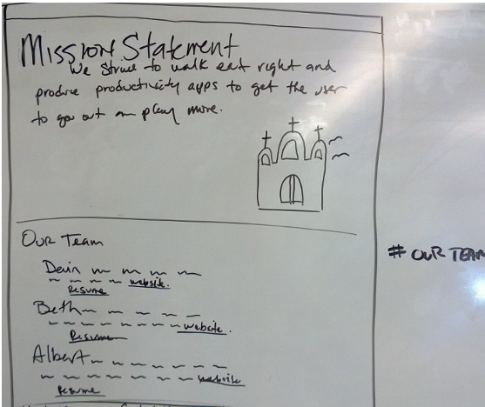

**Scenarios**

Planit scenarios

Register

Traditional:

From Login section of Welcome page

User clicks on the Join Now button

Result: go to register section of the Welcome page

User enters: User Name, Email, Password, Re-enter Password and clicks Start Planit! (Submit)

Result: create a User account

User is taken to the "first time use functionality" of Tree View page

(with greyed out catagories to "click if you want it")

Social:

From Login section of Welcome page

click on Social Login button

User is authenticated through the social site

User clicks Start Planit!

User is taken to the "first time use functionality" of Tree View page

(with greyed out catagories to "click if you want it")

Login

Traditional:

From the Login section of the Welcome page

User enters: User Name & Password

User checks remember me button or not

User clicks the Login button

Store remember me preference

User taken to Tree View page

Or

User is taken to the "first time use functionality" of Tree View page

(with greyed out catagories to "click if you want it") if they have not created any projects

Social Login:

From Login section of Welcome page

click on Social Login button

User is authenticated through the social site

User is returned to the registration page

User clicks Start Planit!

User is taken to Tree View page

or

User is taken to the "first time use functionality" of Tree View page

(with greyed out catagories to "click if you want it") if they have not created any projects

Navigate to project - using compass points or ninja rock

Navigate to project - clicking on project circle

Create a project

Tree View page

Navigate to the root or project that you want to create a project from

Users hovers over the target project / task

Result: sub menu action icon/metaphor appears

User clicks "+" to Create Project

Result: window pops up to:

name (required)

due date (slot machine type selection)(2/3 required)

start date

estimated duration

effort (required)

priority (required)

Notes

reminder setting

User enters required information and submits

Result: project created

Edit your project

Tree View page

User navigates to the project he wants to continue working on

Users hovers over the target project / task

Result: sub menu action icon/metaphor appears

user select "E" for edit

Result: project/task property panel appears

User enters desired changes.

User clicks save button.

Result: project/task is updated

Delete/Remove an existing project

Tree View page

User navigates to the project he wants to delete

User hovers over the target project / task

Result: sub menu action icon/metaphor appears

user select "D" for delete

Result: confirmation dialog appears

User clicks confirm button

Result: project/task is deleted

Navigate to project

User clicks up/down/left/right button

Result: view moves to new location

complete project

Tree View page

User navigates to the project he wants to complete

Users hovers over the target project / task

Result: sub menu action icon/metaphor appears

user selects completion icon

Result: confirmation request

User selects confirm

Result: project visual representation changes to make clear it is complete

**Noun extraction**

Planit is an organization and task management tool for individuals. Users can manage their responsibilities and time by *breaking down* their tasks or projects. Planit gives users the ability to create, delete, edit, and complete task or projects. Planit lets users view their responsibilities in several views: tree, list, schedule, and task view.

User enter project information. The software guides the user in breaking down into smaller pieces and scheduled. The status of a project is available to help users understand whether they will complete the project on time.

Projects are entered into the system where they can be broken down into tasks and given a due date, priority, and status updates to keep the user motivated and abreast of their progress.  The projects can be viewed via a visual tree view, a standard outline view, and list view.  In addition, projects and tasks can be viewed in a calendar.

**Entity Classes**

**User**

**Project Information owner**

**Start date**

**Due date**

**Name/task**

**Priority**

Unlike entity classes, boundary classes are usually easy to extract. In general, each input

screen, output screen, and printed report is modeled by its own boundary class. Recall

that a class incorporates attributes (data) and operations. The boundary class modeling

(say) a printed report incorporates all the various data items that can be included in the

report and the various operations carried out to print the report.

Control classes are usually as easy to extract as boundary classes. In general, each nontrivial

computation is modeled by a control class.

Control - project Controller

progress status

Changes

How complete

Planit points

Schedule

Calendar

Time

Boundary

Views

tree

Outline

Schedule

List

status

**Glossary of Terms**

About Us - The place where the world clicks to learn more about Project6, its mission, and its founders: Albert, Beth & Devin.

Analytics, User based (Phase two) - Data about usage or patterns about the user such as hours spent on a *project* or days left until a project is due.

Analytics View (Phase two) - The web interface where the user can find details about their usage and data about their *projects*

Analytics, Project based (Phase two) - Aggregated data about usage or patterns related to *projects*.

Blog - A place for commentaries on Planit! from around the planet.

Box It - Setting a time frame for a task.

Break Down Warning (Phase two) - This piece of the project is too big, break it down.

Calendar / Schedule View - The web interface that displays the *projects* and tasks in a weekly or monthly view based on when they are scheduled.

Contact Us - The first place a Planit! user will go to find information about the team at Project6 and how to contact us. Email The second place would be Devin's mobile number for the 24/7 hotline.

Cumulative Time - When a task is initiated, the time is zero. As time progresses, "Cumulative Time" increases to give a realistic view of the time invested in the task.

Due Date - The end of the line for the *project.* A date defined by the user to show when the *project* should be completed.

Effort - The user determines an strenuousness/energy level setting for a task as high, medium, or low. If none is given by the user, then it will default to medium.

Estimated Duration - A guess given by the user on how long they think a task will take to complete. If none is given, it will default to zero and all the fab Planit! Points functionality will not be functional. Devin is concerned that the default is zero

Help - The link that directs users to help on how to sign up, log in, how to retrieve forgotten usernames and passwords, with links to: Try it (How To Use) and FAQ’s

Home - After the user has logged in, the portal to exploring Planit! with the following views: Tree View, Outline View, Calendar or Schedule View and Task View.

Login - Where users login or signup.

The Log In area of the Home View will allow for logging in directly or through a social network like Facebook. There will be a link under the Direct Log In area in case the user forgets their Username or Password that links to help in accessing that information. There shall be a Log In button that submits the Username and Password, a Join Now button that links to the view below the fold where a potential user can sign up and a button to log in through Facebook. There shall be a Help link for directions on using the Log In, Forgotten Username or Password, and FAQ�s about Planit.

[DGLAMBERT] Millipede View (Phase two)

Navigation Bar - Menu of functionality that is available in multiple views.

Notifications - Alerts to warn the user of an issue that requires attention: task due dates, burning the candle at both ends and impending doom.

Outline View - The web interface that displays the *projects* and tasks as an outline.

Overload Warning (Phase two)(a notification type) - Danger, Danger Will Robinson! You are overscheduled and can't possibly get it all done in time!

Planit! - A web based time management tool that takes your larger project and breaks it down into smaller tasks so you stay motivated and complete the larger project.

[DGLAMBERT] Planit! Points - A super-secret algorithm that helps the user evaluate the relative size of a project so they can determine if they are crazy to commit to it.

Priority - A measure of relative importance compared to other task. Possible options include: High, Medium, Low

Privacy - Mumbo jumbo legal jargon where you can find out how Planit handles data. www.Planit.Proj6.com/Privacy

[DGLAMBERT] Project - A chunk of work too large to swallow whole.

Reminder (a notification type) - Functionality that allows the user to schedule a reminder for a task.

Scenario - A use case provides a generic description of the overall functionality; a scenario is a specific instantiation of a use case. In general there are a larger number of scenarios, each representing one specific set of interactions.

Snooze Reminders (Phase two) - Just like your alarm clock snooze button, you can postpone a due date.

[DGLAMBERT] Task - A bite size piece of a larger project.

Task View - The web interface that displays the tasks by day.

Terms and Conditions - Mumbo jumbo legal jargon where you can find out how Planit is intended to be used by its users. www.planit.proj6.com/toc

Time Budget (Phase two) - The bank of time you are able to draw from for scheduling tasks in a given time frame

Tree - The hierarchical model of a user’s tasks, displayed using a parent child relationship.

Tree View - The web interface that displays the *projects* and tasks in as a tree.

Use Case - A use case models an interaction between the software product itself and the users of that software product (actors). The label inside the ovals describe the business activities represented by the use case.

User Settings - Preference controls for Planit that each user’s sets based on their individual account.

View - A visual, textual or data centric representation of the *project* or task.